**Course Specialist Year 12 Test Two 2022**

Student name: ________________ Teacher name: ________________

**Task type: Response**

**Time allowed for this task: _____40______ mins**

**Number of questions: _____6______**

**Materials required:** Upto 3Calculators with CAS capability (to be provided by the student)

Standard items: Pens (blue/black preferred), pencils (including coloured), sharpener, correction fluid/tape, eraser, ruler, highlighters

Special items: Drawing instruments, templates, notes on one unfolded sheet of   
A4 paper, and up to three calculators approved for use in the WACE examinations

**Marks available: __41____ marks**

**Task weighting: _10___%**

**Formula sheet provided: Yes**

**Note: All part questions worth more than 2 marks require working to obtain full marks.**

Q1 (2, 3 & 3= 8 marks)

Consider the functions  and 

1. Determine the natural domains of .
2. Does  exist over the natural domain of ? Explain.
3. State the rule and largest possible domain for and its corresponding range.

Q2 (2, 4, 1 & 3 = 10 marks)

The function  is defined below for .

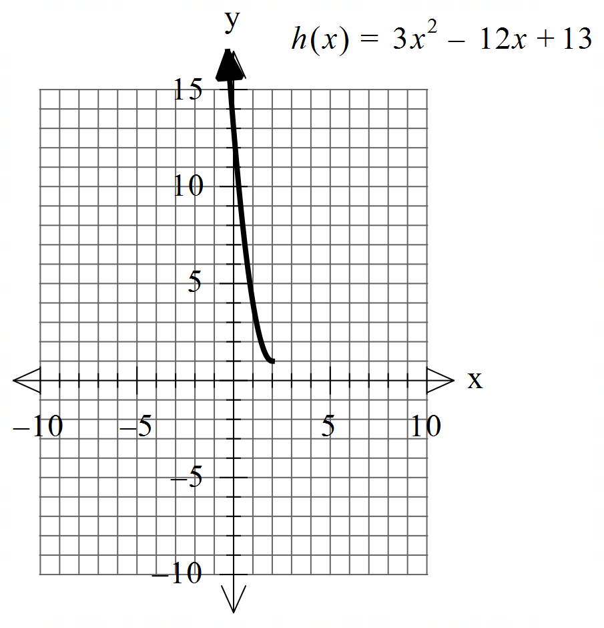

1. Sketch the inverse function  on the axes above.

Q2 continued

1. Determine the rule for and its domain showing **full working**.
2. Determine .
3. Determine the exact coordinates (if any) for where .

Q3 (2 & 3 = 5 marks)

Consider the function  which is plotted below.

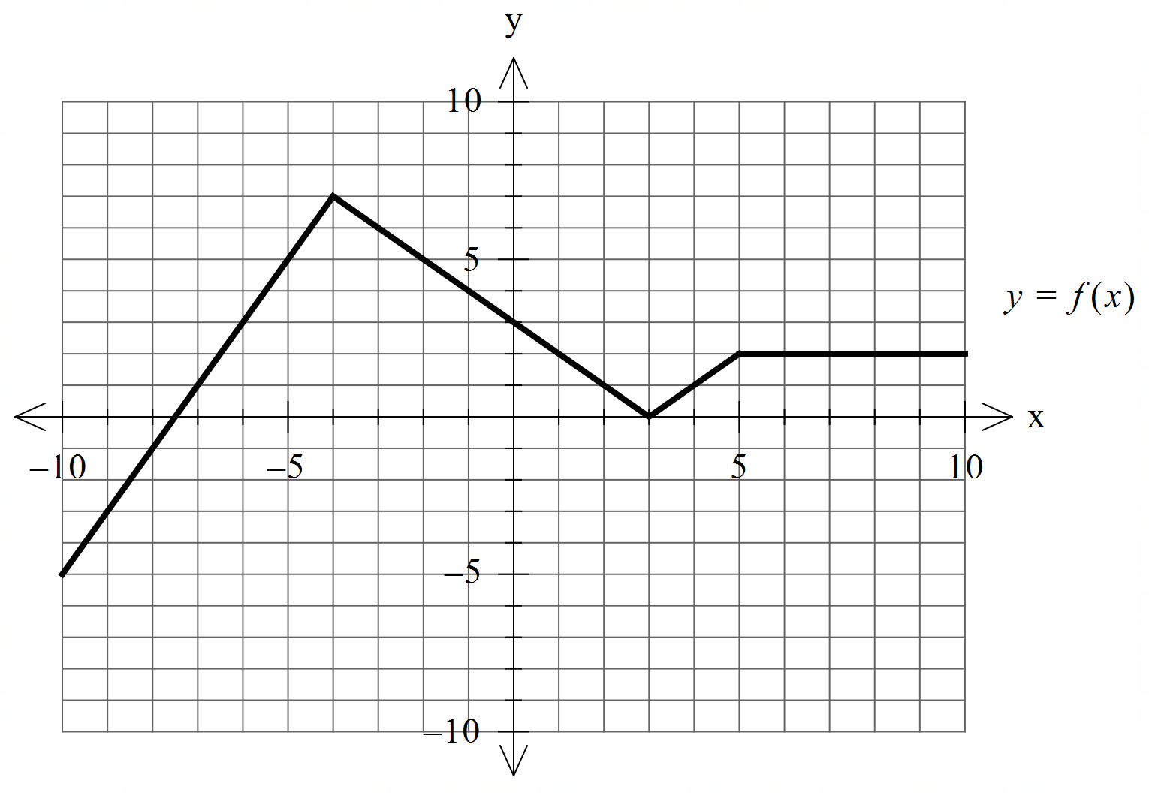

1. Sketch 

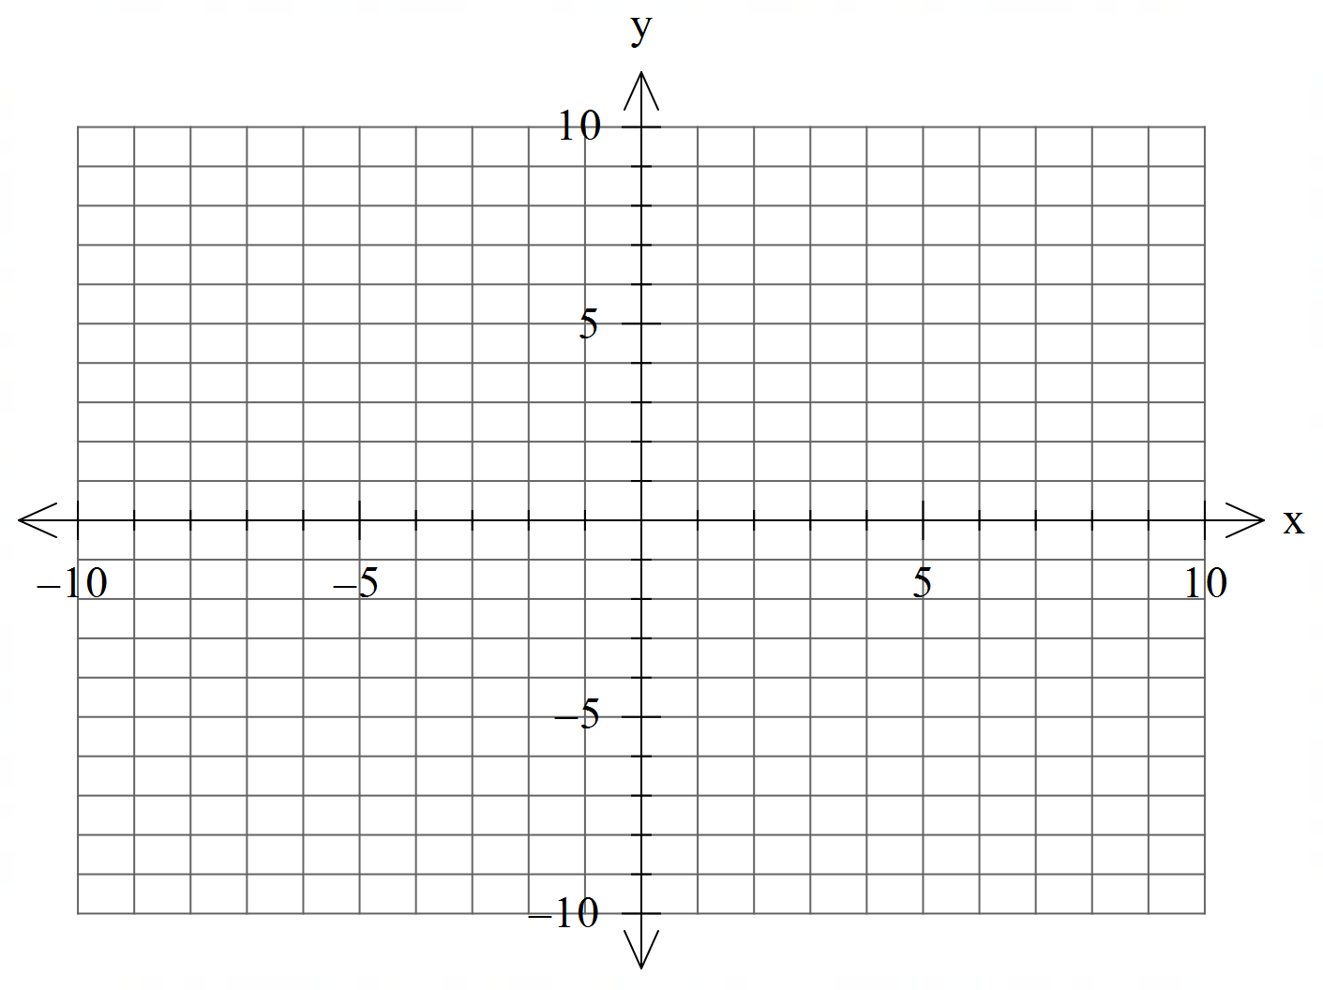

b) Sketch 

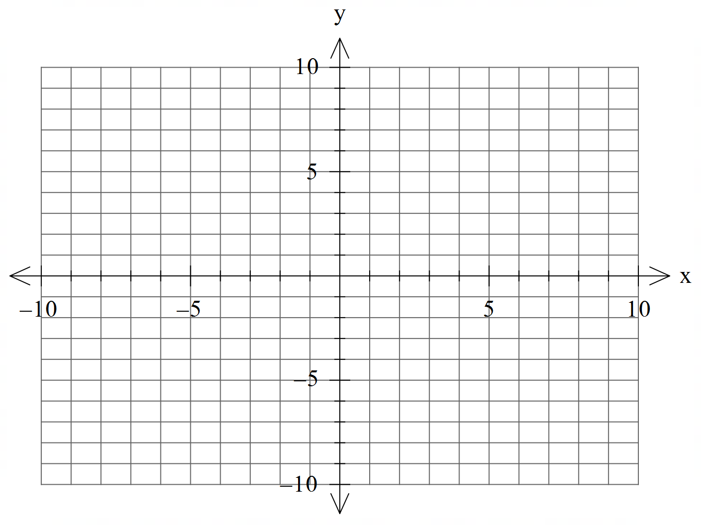

Q4 (4 marks)

Consider two moving objects A & B such that at  seconds  metres and metres per second. Determine the closet approach using **vector** methods.

Q5 (6 marks)

Consider a sphere  with  a constant and the line .

Determine all possible real values of such that:

1. the line meets the sphere at two pints.
2. the line is a tangent to the sphere.
3. the line misses the sphere completely.

Q6 (2, 3 & 3 = 8 marks)

Consider the plane  given by .

1. The point  is on a plane parallel to . Determine the cartesian equation of this plane.
2. Determine the distance between these two planes. Show full reasoning.
3. Consider the lines  and . Determine the distance between these lines.

Extra working space